**Tabel 4.1.1 Entity Types**



**Tabel 4.1.2 Relationship Types**



**Tabel 4.1.3 List Of Attributes**



**Tabel 4.1.5 Keys**



**Tabel 4.1.6 Entity Relationship Diagram**

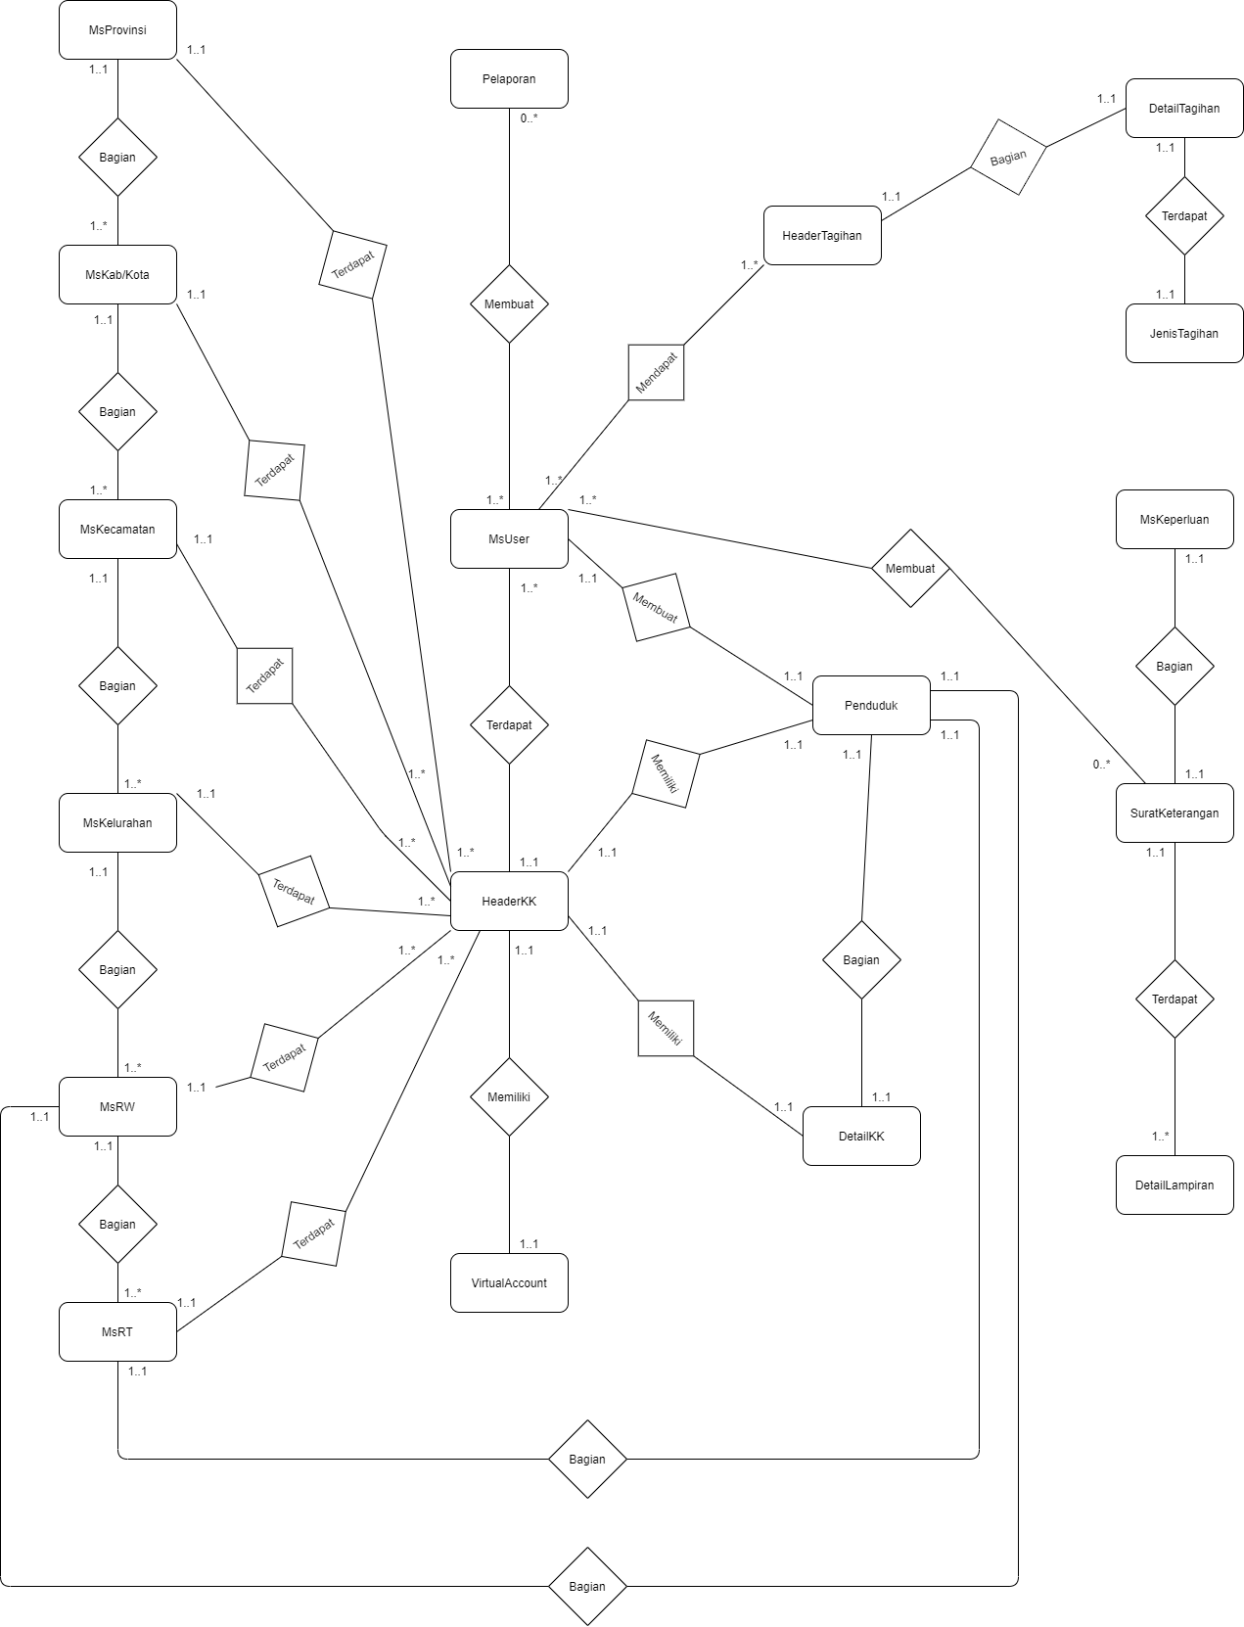

**Tabel 4.3 Class Diagram**

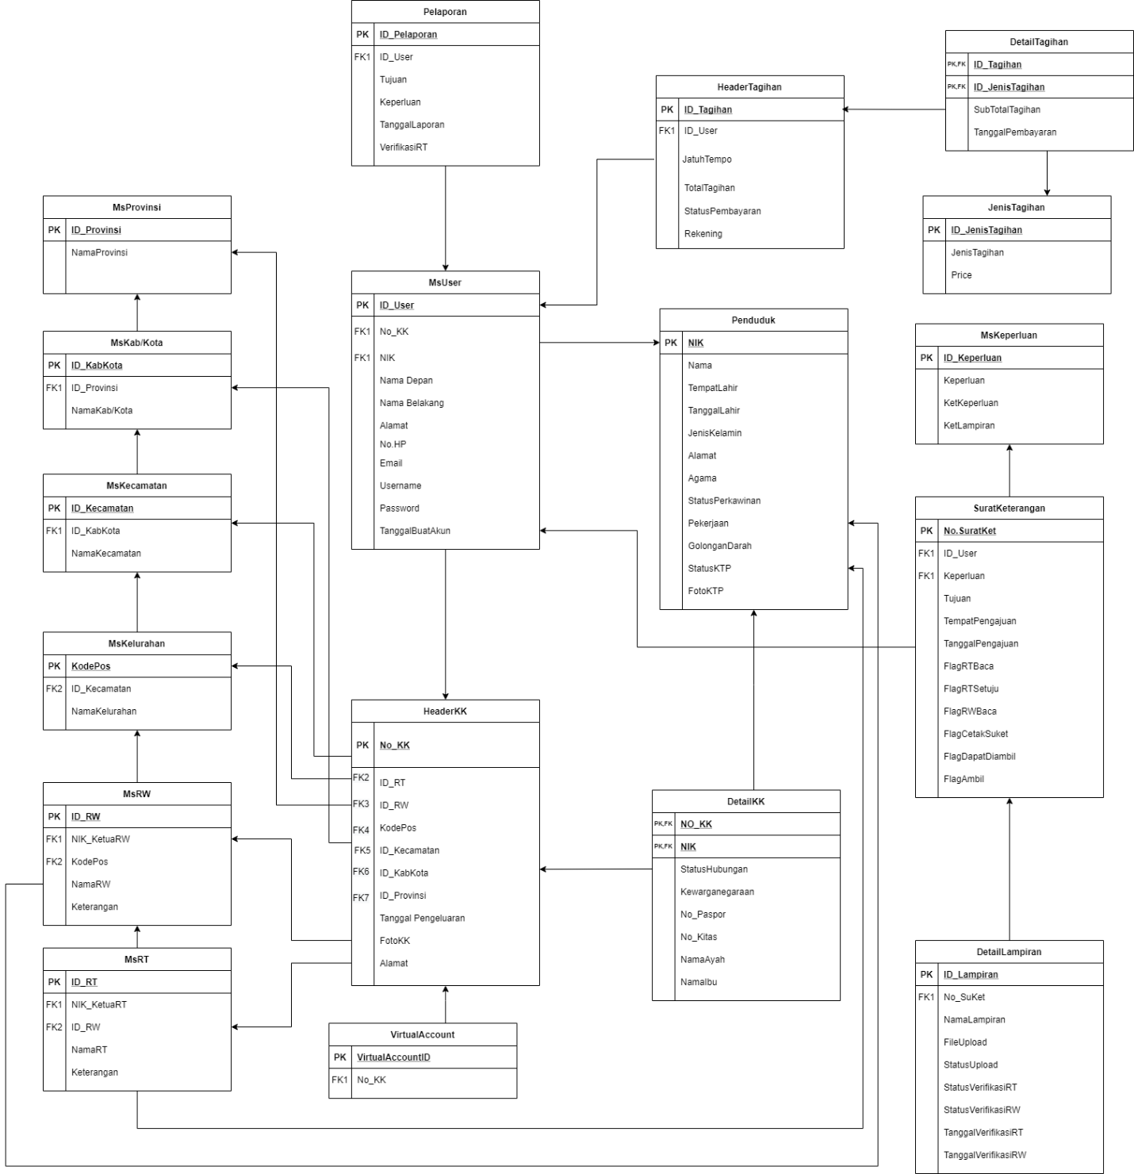

**Tabel 4.3.1 List of Index**



